4D3N YANGON – BAGAN - YANGON
DAY 1: YANGON ARRIVAL – CITY SIGHTSEEING ( L, D )
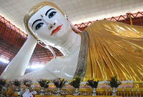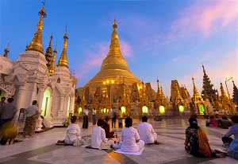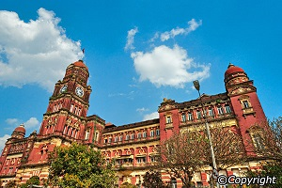
Chauk Htat Gyi pagoda Shwedagon Pagoda Yangon high court building

Arrive at Yangon International Airport. Transfer to your hotel and then visit to the Chaukhtatgyi Reclining Buddha. Enjoy the lunch at restaurants. After lunch, continue to the world famous Shwedagon Pagoda - this Pagoda dates back about 2600years enshrined 8 sacred hairs of the Buddha, claimed to be the world richest golden dome rises 99 meters and plastered onto the sides of this pagoda with 60 tons of pure gold. Dinner & Overnight in Yangon.

Meals: 1 Lunch + 1 Dinner
Accommodation: Overnight in Yangon
The distance: Yangon International Airport - Yangon city: 20km - 40 minutes for transfer.

DAY 2: YANGON – BAGAN SIGHTSEEING ( B/L/D)
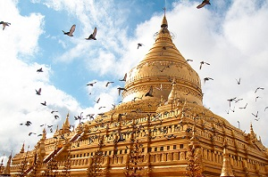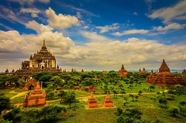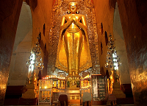
Shwezigon pagoda Bagan panorama Ananda temple

After having breakfast, you will be transferred to the airport for a domestic flight to Nyaung U. As you arrive, we will drive you to your hotel in Bagan to check in. After that, discover Bagan - the land of thousands antiquated pagodas, one after another among green bushes.
Start our trip by visiting Shwezigon Pagoda, the first gold pagoda built in Burma enshrining Gautama Buddha's relics and Ananda Temple, the home of four huge Buddha standing statues - each faces one of the four cardinal directions. Afterward, more temple visitations are carried out as we take you to Gubyaukgyi Temple at Myinkaba - an Indian style pagoda built in 1113 whose exteriors are still in good condition, Htilominlo Temple whose name means "blessings of the three worlds" containing four Buddha images facing four directions on its first floor, and Sulamani Temple - a Buddhist edifice rebuilt in 1994 from which Htilominlo Temple was built after.
Dinner & overnight in Bagan.

Meals: 1 Breakfast + 1 Lunch + 1 Dinner
Accommodation: Overnight in Bagan .
The distance: Yangon city - Yangon International Airport: 20km - 40 minutes for transfer.
Nyaung Oo airport – hotel in Bagan: 8km – 15 minutes for transfer.

DAY 3 : BAGAN SIGHTSEEING - YANGON (B/L/D)
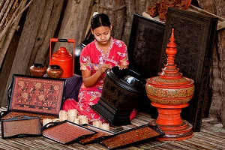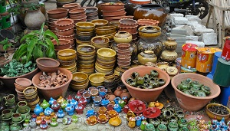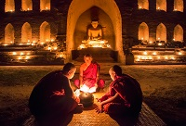
Lacquerware Nyaung Oo market Monks in Bagan
In the morning, head to Nyaung U Market where local products are boisterously bought and sold - you can get some real bargains there as souvenirs.
Then come to lacquer ware workshop to observe what they are made of. Next, visit Dhammayazika, a five-sided pagoda complex where in each side there is a small temple housing a Buddha statue.
In the afternoon, transfer to airport for a flight to Yangon.
Dinner & overnight in Yangon.

Meals: 1 Breakfast + 1 Lunch + 1 Dinner
Accommodation: Overnight in Yangon.
The distance: Bagan - Nyaung Oo airport: 8km – 15 minutes for transfer.
Yangon International Airport - Yangon city: 15km - 40 minutes for transfer.

DAY 4 : YANGON SHOPPING & DEPARTURE (B/-/-)
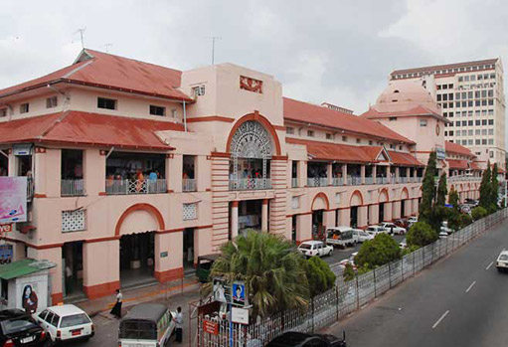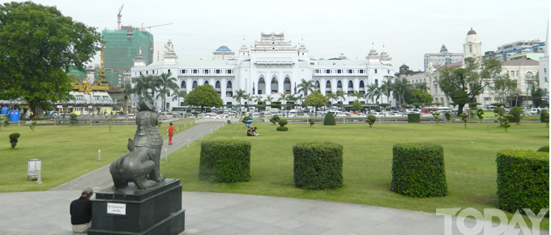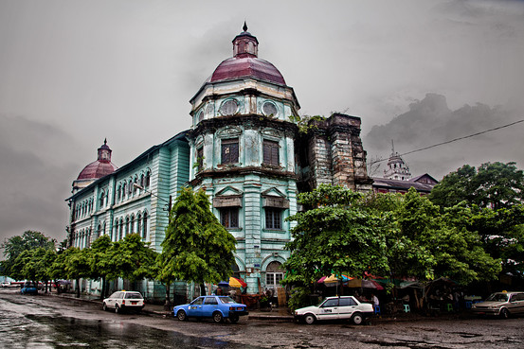
Bogyoke (Scott’s) market Maharbandoola Park Myanmar Heritage Building

After breakfast, shopping to Bogyoke or Scott Market, a famous shopping center to enjoy display of Myanmar handicraft and Gems Shops & enjoy walking tour from Sule Pagoda & visit to the Maharbandoola Park, 48 meters golden dome. And then transfer to Yangon International Airport from Myanmar.

Meals: 1 Breakfast
The distance: Yangon Capital – Yangon International Airport: 20km - 40 minutes for transfer.

SEQUENCE OF ITINERARY SUBJECT TO LOCAL ARRANGEMENT
PRICE INCLUDE:
- Accommodation – as hotel in the list or similar – based on Twin/Double/Triple sharing
- Tour guide: English speaking guide during the tour.
- Shows and sightseeing in schedule.
- Transportation by private air-conditioner.
- 01 bottle (500 ml) of drinking water for each pax per day.
- Meals (Burmese Food & Chinese Food) as the tour code ( B: Breakfast, L: lunch, D: Dinner)
- Domestic flights mentioned

PRICE EXCLUDE:
- International flight ticket & airport tax
- Personal expenses: Tel, Fax, Mini Bar, Laundry,etc.
- Personal travel insurance
- Compulsory Tip for local guide and driver (USD/PAX/DAY)

Group Size | Tips in USD
2 – 4pax | 6
5-7pax | 5
8 - up | 3
- Surcharge with other languages guide.
- Surcharge at hotel case by case
  - Burmese New Year (TBA)
  - Gala Dinner on X’Mas (24 Dec) & New Year (31 Dec)

Hotel listed or Similar |  | All rates are next in USD/pax  valid for LOW SEASON from 01 May 19 to 30 Sep 2020
 |  | Tour by private car / bus with private guide
YANGON | BAGAN | 2 | 3-4 | 5-6 | 7-9 | 10-12 | 13-15 | 15+1 | 20+1 | 25 +1 | 30+1 | SGL SUP
Grand United Ahlone  Grand United China Town 3*  Grand United donwntown -21st str 3* | Yadanarbon Bagan 3*  The Regency 3* | 560 | 500 | 485 | 465 | 440 | 430 | 430 | 420 | 415 | 410 | 45
Taw Win Garden 4* | Amazing Bagan 4*  Treasure 4*  Thiripyitysaya Sanctuary 4* | 605 | 545 | 525 | 505 | 480 | 475 | 475 | 460 | 455 | 450 | 80
Park Royal 5*  Chatrium 5* | Bagan Lodge 5*  Aureum Palace 5* | 650 | 590 | 570 | 550 | 530 | 520 | 520 | 510 | 500 | 500 | 165

Hotel listed or Similar |  | All rates are next in USD/pax  valid for HIGH SEASON from 01 Oct 18 to 10 Apr 19
 |  | Tour by private car / bus with private guide
YANGON | BAGAN | 2 | 3-4 | 5-6 | 7-9 | 10-12 | 13-15 | 15+1 | 20+1 | 25 +1 | 30+1 | SGL SUP
Grand United Ahlone  Grand United China Town 3*  Grand United donwntown -21st str 3* | Yadanarbon Bagan 3*  The Regency 3* | 580 | 520 | 505 | 485 | 460 | 450 | 450 | 440 | 435 | 430 | 95
Taw Win Garden 4* | Amazing Bagan 4*  Treasure 4*  Thiripyitysaya Sanctuary 4* | 635 | 575 | 555 | 535 | 510 | 500 | 500 | 490 | 485 | 480 | 145
Park Royal 5*  Chatrium 5* | Bagan Lodge 5*  Aureum Palace 5* | 730 | 670 | 650 | 635 | 610 | 600 | 600 | 590 | 585 | 580 | 235

NOTE
The timing of sightseeing points shall be fixing by local operator due to traffic and weather conditions, however all points must cover unless amendment or cancellation make by clients themselves (Non-refundable for any cancellation that made by clients)

Tour and price are subject to change without notice or incase of deduct number of pax in quoted group.

Small deviations in the tour program are sometimes necessary, depending on weather, road conditions, flight schedules and room availability.

Supplement charge for room rate in peak dates depends on the hotel category used. Compulsory gala dinner on X’mas, New Year’s Eve & Water Festival days to be advised upon booking. Prices for group of 15 persons up in 5 stars hotels sometime requires to re-quote bases on the hotel policy.

Group tour 16pax, you will get 01 FOC for tour leader based on twin sharing basis include breakfast (domestic air ticket is not applicable)

BUS

Group Size | Kind of Transportation
1-2 pax | 4 seater
3 pax | 7 seater
4-9pax | 16 seater
10-18 pax | 30 seater
19-21 pax | 35 seater
22 – 42 pax | 45 seater

CHILD POLICY

- Infant below 2 years old sharing same room with parents is free of charge.
- Child below 12 yrs old sharing same room with 1 ADL is charged for 90%.
- Child below 12 yrs old with extra bed and sharing same room with parents is charged for 65%.
- Child below 12 yrs old No extra bed & sharing same room with parents is charged for 55%.

TERM & CONDITIONS

1. CANCELLATION
In case of cancellation, fees will be charged accordingly to the day that official notice in writing is received at Hanoi Office: No 11, lane 8, Doi nhan, Ba Dinh district, Hanoi-Vietnam.
- Before 30 days: No charge
- Less than 30 days: 50% of total tour price
- Less than 14 days: 75% of total tour price
- Less than 7 days before arrival date or no-show: 100% of total tour price

Any cancellation due to irresistible reasons such as wars, strikes, earthquakes, etc. will be considered subject to each case.

